

RT Systems Lab

**Weekly Report number (4)**



Contact Us

Julian Ewaied 215543497 Namir Ballan 326165156

Contents

This Week's Tasks 3

Building more interactive depth-map 3

Presenting 3D results 4

Making the code more elegant 5

Making the code more efficient 6

Next Week's Tasks 7

# This Week's Tasks

* Checking the rotation is done well
* Matching between two representations of the same point in two different frames
* Making the code more efficient
* Automating the filtering policy

## Checking Rotations

We checked the rotations, and they looked fine. Next, we looked at the output more precisely.

We started by looking at the 3D representation as it is more flexible, and noticed something odd in the output when we zoomed in:

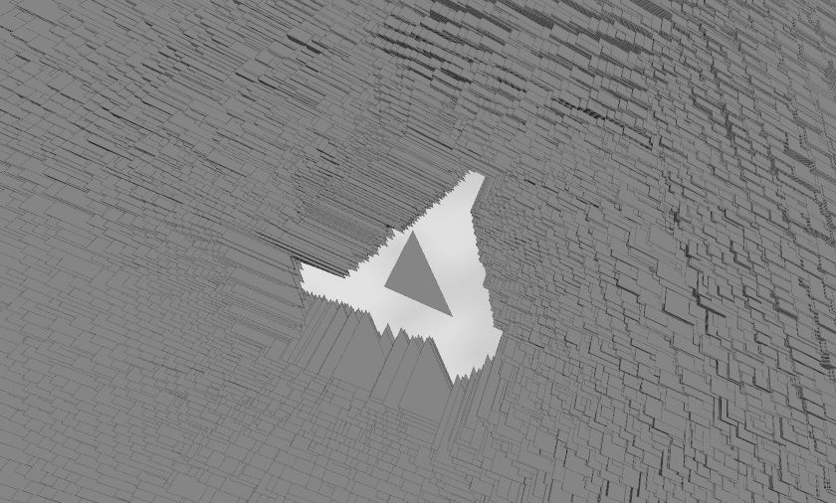

The shape of the rooms was actually well calculated, just covered with way too many outliers! This made our next mission very clear – finding the best filtering policy.

## Automating Filtering Policy

We considered multiple options, of which we mention the following:

1. Manually decided bounded interval of SAD values, which we found ineffective last week.
2. ML the boundaries, which is currently unsupervised meaning not possible.
3. Using computational geometry algorithms, of which we needed to do some more research.

## Matching Points

We can notice that points that we get are points with a shifted height